A REVIEW OF INLAND CONTAINER DEPOTS

A dissertation submitted to the Indian Maritime University in partial fulfillment of the requirement for the award of the degree of

MASTERS OF BUSINESS ADMINISTRATIVE
(International Transportation And Logistics Management,)

by
Sarath R Pillai
Registration No 2005305028


INDIAN MARITIME UNIVERSITY
SCHOOL OF MARITIME MANAGEMENT
KOCHI CAMPUS

May 2022
Under the guidance of
Dr Yogamala HL
(Head of Maritime Management)

Declaration
I certify that the project report entitled “A Review of Inland Container Depot” submitted by me to Indian Maritime University, Kochi campus in partial fulfillment of the requirement for the award of the degree of MBA in(International Transportation And Logistics Management) is a record of bonafide project work carried out by me under the guidance of Dr Yogamala HL (Head, School of Maritime Management).
I further declare that the work report reported in this project has not been submitted and will not be submitted either in part or in full, for the award of any other degree or diploma in this University or any other University

Name of the student:
Signature:
Date:

Supervised by:
Designation:

Acknowledgments
Primarily I would thank God for being able to complete this project with success. Then I would like to thank my Professor Dr Yogamala HL (Head, School of Maritime Management), whose guidance has helped me patch this project and make it a full proof success. Her suggestion and her instructions have served as the major contributor towards the project.
Then I would like to thank my family and friends who have helped me with their valuable time and suggestions which has been helpful in various phases of completion of the project.
Also a special thanks to online platforms in helping me get all the data and specifics needed in order to complete the project, at this time of crisis.

Abstract
This project focus on providing the accurate and the best information available on dry ports also known as Inland Container Depot in India.
Inland containers depots are a major part of logistics world and the shipping industry as they act as the expandable memory or moreover the extra storage space available for the sea ports, they also play an immense role in logistics by providing the services of containers. They provide hinterland services for all cargos by providing access to domestic and also international transportation within their particular geographic range. The network formed by having more of inland container depots is immense; this will wildly increase the growth rate of the particular country having the major number of dry ports.
The study provides an analysis and methodological study on the topic of inland container depots. It takes into the account the procedures and functions related with inland ports and also give a brief explanation on how the present pandemic has affected the dry ports in India and throughout the world.
Around the globe we see a growing trend of increasing dry ports, this is because of the basic knowledge of increasing the ratio of exports and imports in the country. As we know that a countries’ growth rate is accounted by the quantity of exports the country does and so comes to the need of dry ports, which provide the necessary storage and also acts as a perfect substitute for administrative functions of the export and import cargos.
Going through the project you will even more understand the role an inland container depot plays in the processes of a sea port and also the extra hand and increase of efficiency the addition of a dry port can make towards logistics and the export import industry.

Abbreviations
CBEC- Central Board of Excise and Customs
LCL- Less than container load
LCS- Land Customs station
CONCOR - Container Corporation of India Ltd
CFS- Container freight station
ICD- Inland container depot
YOR- Yard Occupancy Ratio
CMC- Cubic Minimum Capacity
ISO- International Organisation For standard
H&T-Heavy Tested
DCT- Delivered Container Terminal
DO- Delivery Order

Glossary

Table of contents Page No.

Declaration…………………………………………………………………………… ()
Acknowledgement……………………………………………………………………. (ii)
Abstract…………………………………………………………………………. ……..(iii)
Abbreviations…………………………………………………………………………. (iv)
Table of Contents
Chapter-I
1.1 Introduction………………………………………………………….8
1.2 Background…………………………………………………………8
1.3 Problem identification……………………………………………..8
1.4 Research objective…………………………………………………9
1.5 Scope of study………………………………………………………9
1.6 Dissertation structure……………………………………………….9
Chapter-II
2.1 Research Methodology…………………………………………….10
2.2 Research design…………………………………………………….11
2.3 Qualitative study…………………………………………………….11
2.4 Analysis approach…………………………………………………..12
2.5 Methodology limitation……………………………………………..12
Chapter-III
3.1) Inland container depots………………………………………………14
3.2) Advantages of Inland Container Depots…………………………...14
3.3) History of Inland Container Depot…………………………………..16
3.4) Functions of ICDs……………………………………………………..16
3.5) Procedures at ICDs……………………………………………………18
3.6) Organizational Structure of an ICD…………………………………..21
3.7) Problems faced by ICDs……………………………………………...22

Chapter-IV
4.1) National Inland Container depots…………………………………..24
4.2) Suggestions ………………………………………………………….26
4.3) ICDs in India…………………………………………………………..26
4.4) Challenges and opportunities of ICDs…………………………….27
Chapter- V
5.1) Conclusion………………………………………………………….29
5.2) Covid-19 affecting ICDs…………………………………………..29
5.3) Bibliography………………………………………………………..31
5.4) Figures………………………………………………………………32

CHAPTER- I
INTRODUCTION

1.1 Inland Container Depot

Inland Container Depots, otherwise known as ICDs, are dry ports equipped for handling and temporary storage of containerized cargo as well as empties. This means that hinterland customers can receive port services more conveniently closer to their premises.
A dry port (sometimes inland port) is an inland intermodal terminal directly connected by road or rail to a seaport and operating as a centre for the transshipment of sea cargo to inland destinations. A container freight station (CFS) is a facility where freight is consolidated (grouped) or deconsolidated (separated) between shipping legs. CFS facilities are typically based in close proximity to a port where cargo is processed.

1.2 Background

This project covers the study of Inland Container Depots (ICD)
- The various processes involved in the running of ICDs
- Important inland ports in the world.
- Introduction and history of ICD in India.
- List of ICDs available in India are mentioned with their respective locations.
- Challenges and opportunities for ICDs in India.
- A copious conclusion to the project.
- How covid -19 has affected the ICDs and suggestions to overcome this fall off.
For providing the best of content an ample amount of information was required and it was collected from various sources. The filtering and listing out of the most apt information is done and included in the project.
1.3 Problem identification
- Location of the inland container depot is one issue
- A hinterland ICD would need at least seven to 10 industrial corridors for its utilization level to remain strong.
- The location of an ICD should be such that it is surrounded by an industrial
area within a radius of 20-25 km. Only then will the business be viable.
- The lack of rail and road connectivity, the backbone of an efficient ICD network, is another.
- Rail and road connectivity network to the ICDs is not sufficient and a lot more needs to be done in this area rather than the government’s plan of refurbishing ICD facilities alone.
- Private companies entering the industry are extremely cautious.
- Inadequate road networks within the port area, inadequate cargo-handling equipment and machinery.
1.4 Research objective
This study on ICDs provides the information and details about the processes, problems present in ICDs and various locations they are situated in. It depicts the importance in role of ICDs in logistics, shipping and various other lines of business.
The problems faced by ICDs are outlined and the preventions and precautions taken in order to avoid the shortcomings are also explained. The solutions for the respective problems are also learnt from this project.
This is a well developed research project, hoping to cover all sides of ICDs.
1.5 Scope of study
The study covers the various aspects of Inland container depots and their problems, present day functioning, developments made throughout the years.
This project mainly taking the help from the internet and various other resources has the information provided from second hand and not information made up from self so the profundity of the study is limited.
Thus said the project still covers the maximum outlook of the topic with the provided resources.
1.6 Dissertation structure
- Declaration
- Acknowledgement
- Abstract
- Table of contents
- Chapter 1
- Chapter 2
- Chapter 3
- Chapter 4
- Conclusion
- Bibliography

CHAPTER- II
RESEARCH METHODOLOGY

2.1 Methodology
The research methodology used to conduct this study is secondary data analysis This refers to the usage of the data and information relevant to the topic that was already collected during conduction of various studies. The advantage of using secondary data is that, it is economical. Someone else has already collected the data, so there is no need to devote money, time, energy and resources to this phase (collection of data) of research. A second major advantage of using secondary data is the breadth of data available. This allows considering the trends and changes of phenomena over time. A third important advantage of using secondary data is that the data collection process often maintains a level of expertise and professionalism that may not be present with individual research or small research projects.
2.1.1 Methods used for collection of secondary data
- Data available on the internet: One of the most popular ways of collecting secondary data is using the internet. Data is readily available on the internet and can be downloaded at the click of a button.
- Government and nongovernment agencies: Data for secondary research can also be collected from some government and non-government agencies. For example, US Government Printing Office, US Census Bureau, and Small Business Development Centers have valuable and relevant data that businesses or organizations can use.
There is a certain cost applicable to download or use data available with these agencies. Data obtained from these agencies are authentic and trustworthy.
- Public libraries: Public libraries are another good source to search for data for secondary research. Public libraries have copies of important research that were conducted earlier. They are a storehouse of important information and documents from which information can be extracted.
- The services provided in these public libraries vary from one library to another. More often, libraries have a huge collection of government publications with market statistics, large collection of business directories and newsletters.
- Educational Institutions: Importance of collecting data from educational institutions for secondary research is often overlooked. However, more research is conducted in colleges and universities than any other business sector.
The data that is collected by universities is mainly for primary research. However, businesses or organizations can approach educational institutions and request for data from them.
- Commercial information sources: Local newspapers, journals, magazines, radio and TV stations are a great source to obtain data for secondary research. These commercial information sources have first-hand information on economic developments, political agenda, market research, demographic segmentation and similar subjects.
Businesses or organizations can request to obtain data that is most relevant to their study. Businesses not only have the opportunity to identify their prospective clients but can also know about the avenues to promote their products or services through these sources as they have a wider reach.
2.2 Research Design
The research design refers to the overall strategy that you choose to integrate the different components of the study in a coherent and logical way, thereby, ensuring you will effectively address the research problem; it constitutes the blueprint for the collection, measurement, and analysis of data. A number of approaches are used in this research method design. The purpose of this chapter is to design the methodology of the research approach through mixed types of research techniques. The research approach also supports on how to come across the research result findings.
Research design is a guide for selecting sources and type of information.
To conduct meaningful secondary analysis, a significant time is spent reading and learning about the origins of the data sets. Through careful reading and vetting we can understand the purpose for which the material was collected or created and the methods used to collect it.
2.2.1 The research design follows the following steps-
- Collection of data from reliable sources related to the topic.
- Dividing the data to various subdivisions.
- Filtering the available data of various subdivisions in relation to the header.
- Finding problems within the subdivisions.
- Solution to the problems.
- Forming a proper structure of presentation.
- Preparing the presentation.
- Forming a conclusion.
The first part gives a highlight about the dissertation design. The second part discusses about qualitative and quantitative data collection methods. The last part illustrates the general research framework.
2.3 Qualitative study
This is the part of study conducted in order to uncover trends in thought and opinions, and dive deeper into the problem and also for understanding of underlying reasons, opinions, and motivations through open-ended and conversational communication. This method is not only about “what” the topic is but also what comes to a person’s mind when he or she hears the topic (inland container depots) and also answering the various questions arisen with the topic.
2.3.1 The method used in this case is grounded theory.
Grounded theory- Grounded theory involves the collection and analysis of data. The theory is “grounded” in actual data, which means the analysis and development of theories happens after collecting the data.
Steps involved-
- Acknowledging self
- Adopting a perspective
- Analyze and interpret data
The qualitative study is done by the data which has already been formed and therefore only an analysis is done on the collected data and is presented.
Also some commonly asked questions about the topic is collected and answered in the next chapter as a part of the qualitative study of the topic.
2.4 Analysis
The process of breaking down a something into its parts to learn what they do and how they relate to one another. This helps to study in a deeper manner
There are various stages of analyzing the data and in different stages of analytics huge amount of data is processed at various steps. Depending on the stage of the workflow and the requirement of data analysis, there are four main kinds of analytics – descriptive, diagnostic, predictive and prescriptive.
Descriptive Analytics: Describing or summarizing the existing data using existing business intelligence tools to better understand what is going on or what has happened.
Diagnostic Analytics: Focus on past performance to determine what happened and why. The result of the analysis is often an analytic dashboard.
Predictive Analytics: Emphasizes on predicting the possible outcome using statistical models and machine learning techniques.
Prescriptive Analytics: It is a type of predictive analytics that is used to recommend one or more course of action on analyzing the data.
There are two stages of analysis in order to solve the identified problems of the topic, the descriptive analytics and prescriptive analytics.
2.5 Methodology limitations
There are various limitations with the methods used in order to conduct the study and are mentioned here.
- The data can be general and vague and may not really help companies with decision making.
- The information and data may not be accurate.
- The data maybe old and out of date.
- The sample used to generate the data may be small.
- The subjectivity of the data leads to difficulties in establishing reliability and validity of approaches and information. It is difficult to detect or to prevent already-induced bias.

CHAPTER- III
SCRUTINY OF INLAND CONTAINER DEPOTS

3.1 Inland container depots
India with one of the longest coastline with over 7500 km, has 12 major and 185 Non-major ports, this sea ports have a support of around 300 dry ports of which around 40% is owned by CONCOR
Container depots occupy an important part in the global supply chain. They manage the smooth flow of cargo for the shippers, shipping lines and forwarders and leasers in general. The container depot is contracted to consolidate the goods which are then loaded on to the ship. Apart from being a consolidation point, it is also a station for container maintenance services such as repair, cleaning or inspection. Empty containers that belong to leasing companies or shipping companies are stored here to be reused or repositioned. It is an exchange market for importers and exporters to sell or buy container assets.
A container depot can act as an extended part of the port like a satellite terminal because of its high flexibility with opening hours and access. Many times, it is a more affordable place to store containers than at the terminals at the port. When there is high congestion at the terminals, empty containers can be brought to be stored at the depot and then used for export activities. Containers that need to be repositioned can be brought to the terminal outside peak hours. Hence, the container depots act as a buffer for the terminals by storing empty containers which are a low-value activity that is taking valuable real estate at the terminals.
The container depot location is an important feature. A container depot located close to the terminals helps reduce the number of movements. Depots are located close to the ports and in hinterlands, known as inland container depots (ICDs). If it is a metropolitan area where there is high density at the terminals, container depots near the ports can respond better to the freight distribution services and can have an easing effect when it is part of the logistics chain.
3.2 Advantages of Inland Container Depots
One of the benefits of having dry ports is their ability to relieve the issues of storage and customs space that frequently plagues seaports. Ports located along the ocean have a limited amount of space, which is far less than is sometimes necessary to handle the large quantities of goods coming in. They help reduce the competition of companies trying to get their goods stored temporarily before they embark onward to their destinations.
Another benefit is the ability of a dry port to speed up the movement of cargo between ships and inland transportation systems that distribute the goods. This helps maintain dry ports as central distribution hubs for a massive amount of goods, as the import and expert of goods becomes quicker.
Dry ports are specialized facilities that are designed to process standardized shipping containers used within international transport. The use of these shipping containers makes it easy to move goods off of a ship and onto a tractor-trailer, train, or another ship. The transported goods only need to be unloaded once they arrive at their final processing destination.
Dry ports also act as a cost-effective distribution channel between seaports and high-capacity rail. The entire process becomes more efficient, thanks to this link existing within the supply chain. Collection of the containers is simple and fast, allowing for goods to reach their final destinations quicker, at a lower price.
There is even an environmental benefit to using dry ports. One study had found that when dry ports are used in the supply chain, CO2 emissions are roughly 25% lower than they normally would be. That is a significant reduction in pollution caused by the transportation of goods
For most exporters, importers, Customs house and shipping line agents, and even Customs officers, there is no difference between Container Freight Stations (CFS) and Inland Container Depots (ICD). In both the places, the imported goods or export goods are ordinarily kept before clearance by the Customs and where filing of Customs manifests, bills of entry, shipping bills declarations, assessment and all the activities related to clearance of goods for home consumption, warehousing, temporary admissions, re-export, temporary storage for onward transit and outright export, transshipment etc, takes place. So, CFS and ICD mean the same thing However, they do not mean the same facility, says the Central Board of Excise and Customs (CBEC).
A recent CBEC circular clarifies that CFS is merely an appendage to a parent Customs station at a port, airport, land Customs station (LCS) or ICD. An ICD is a Customs station in its own right having independent existence on a par with any Customs station at a port, airport or LCS. A CFS is an extension of a port/airport/LCS/ICD customs station, set up with the main objective of decongesting the ports, where only a part of the customs process is done.
At CFS, goods are stuffed into containers or de-stuffed and aggregation/segregation also takes place. Custom’s functions of a CFS such as processing of manifest, import/export declarations that are filed by the carrier/importer/exporter and assessment of bill of entry/shipping are performed in the Custom House/Custom Office that exercises jurisdiction over the parent port/airport/ICD/LCS to which the CFS is attached. In the case of customs stations where automated processing of documents has been introduced, terminals have been provided at such CFSs for recording the result of examination. In some CFSs, extension of service centers have also been made available for filing documents, amendments etc. However, the assessment of the documents is carried out centrally.
On the other hand, an ICD would have an automated system of its own with a separate station code [such as INTKD 6, INSNF6, etc] allotted by the Directorate General of Systems and with the inbuilt capacity to not only enter examination reports but also to enable assessment of documents, processing of manifest, amendments, etc, says the CBEC. So, a Commissioner can approve a standalone ICD but not approve a standalone CFS.
So, for an importer, exporter, customer house agent or shipping line, how does it matter whether a place is designated as a CFS or ICD?
Essentially, movement of goods from a port, airport or LCS to an ICD shall be in the nature of movement from one custom station to another custom station and will be covered by Goods Imported (Condition of Transshipment) Regulations, 1995. In contrast, movement of goods from a customs station at port/airport/ LCS/ICD to a CFS would be akin to local movement from a custom area of a customs station to another custom area of the same station and such movement is covered by local procedure evolved by the Commissioner of Customs and covered by bonds, bank guarantee, etc.
3.3 History of Inland Container Depot (CONCOR)
Indian Railway's strategic initiative to containerize cargo transport put India on the intermodal freight transport map for the first time in 1966.
Given India's size (almost 3,000 kilometers from North to South and East to West), rail transport is often a cheaper option for all cargo over medium and long distances, especially if the cost of inter-modal transfers can be reduced. Seeing that containerized multi-modal door-to-door transport provided a solution to this problem, In 1966 Indian Railways entered the market for moving door-to-door domestic cargo in special containers.
Although the first ISO container in India had been handled in Kochi as early as 1973, it was not until 1981 that the first ISO container was moved inland by Indian Railways to the country's first ICD at Bangalore, also managed by the Indian Railways.
Expansion of the network to seven ICDs by 1988 saw an increase in container handling capacity, while along the way a strong view emerged that there was a need to set up a separate pro-active organization to promote and manage the growth of containerization in India.
Container Corporation of India Ltd. (CONCOR) Incorporated in March 1988 under the Companies Act. CONCOR commenced operations in November 1989 taking over an existing network of seven inland container depots (ICDs) from Indian Railways.
CONCOR is a Navratna Public Sector undertaking under the Indian Ministry of Railways.
CONCOR is providing single window clearance facility at their ICDs for domestic & international trade. It has set up various ICDs across the country. With view to growing domestic & international trade in India, a demand of Inland Container Depot (ICD) and its importance has replaced the traditional style of cargo movement & handling.
In India, there is immense scope of domestic and international trade. There are many manufacturing units are set up in the industrial area of India. There are also various natural resources of minerals available. This area gifted is with the agricultural inflows also. The commodities like Steels, Scraps, Polymers, Waste Papers, Pulses and Plastic materials can be the potential commodities for domestic & international trade.
CONCOR’s Inland Container Depot, Tughlakabad is the largest ICD in India. Spread over 44 hectares of land in National capital region, it handles nearly a million containers annually. According to Ministry of Shipping, Government of India, around 95% of India’s trading by volume and 70% by value is done through maritime transport. In such a scenario, a dry port or Inland Container Depot is employed to relieve a sea port of some workload and congestion.
3.4, Functions of ICD
3.4.1 Dispatch/delivery of cargo-
Before the vessel arrives, the port authority will berth a vessel without delay and that adequate discharging equipment and labour are available. Handling, transporting and storing each shipment are labour-intensive operations. Unless provided in the contract of carriage on the Bill of Lading, the receiving agent must arrange stevedoring contracts for equipment and labour to discharge, handle and move the cargo to the assigned in-port storage area or to dispatch the cargo out of the port. The port authority or companies licensed to operate within the port may offer these services.
3.4.2 Survey of cargo and containers from reputed surveyor-
A container surveyor usually conducts inspections, surveys and examinations of container equipment either before or after a company lease a container to make sure container is in condition. A Cargo surveyor is normally appointed by the Cargo Owner, but he may be appointed by the cargo receivers, owners, insurers or any other stake holders in the industry. His job varies from determining the actual cargo loaded on board or to check the condition of the cargo as being loaded / discharged.
3.4.3 Stuffing and stripping of containers-
The packing and unpacking of containers is called stuffing and stripping of containers. Container Stuffing is important to avoid cargo overflow or wastage of space, it is essential for shippers to have a stuffing plan before cargo is loaded into the container. It becomes especially important when the shipment has more than a few containers where it becomes important to optimize the weight and volume over multiple containers. A small change in design can lead to a big gain in efficiency and can lead to lower costs.
3.4.4 Computerized operations and business transactions-The ICDs are adopting digital technologies in order to fast-track the entire container handling process. The entire processes involved in the depots have been computerized and therefore an easier transaction and smooth operations takes place.
3.4.5 Modern Communication facility-The maritime industry is a global transporter of the goods of modern globalized economies. Shipping plays a vital role in today’s economy, with over 90% of the world’s trade carried by sea. In order to improve the safety and efficiency of maritime transport and the protection of the sea and marine environment, it is inevitable to use modern information and communication technologies when collecting, storing, processing, presenting and distributing relevant data and information to the participants in maritime transport. The Smart Port used information technology (IT) extensively to create a high-tech port. The key factors contributing to the success of the IT and communication infrastructure in the Smart port are the ability to meet the changing demands of users and to keep up with the rapid developments in IT and the ability to accommodate new technology developments without having to constantly restructure. The key issues related to navigation systems, communication networks and information technology and its applications to secure the ships and the development of business performance for the transfer and circulation of goods within the seaports with high efficiency and the impact of this on the national economy.
3.4.6 Transit operations Inland intermodal terminals (or dry ports) are thus mushrooming, connected to seaports by rail, road or inland waterways. As such, inland intermodal terminals are usually developed close to railway and motorway junctions to facilitate the transfer of containers between modes of transport, favoring, to the extent possible, the more environmentally friendly transport modes, such as rail and inland waterways.
3.4.7 Customs clearance-
Customs clearance is the act of taking goods through the customs authority to facilitate the movement of cargo into a country (import) and outside the country (export). Also, the customs clearance means a document issued by the customs authority to a shipper indicating that all duties have been paid and the shipper’s goods is cleared for export.
3.4.8 Fumigation of containers-
The fumigation process involves the release of phosphine gas in a controlled way from a solid form of aluminum phosphide. This is done over a period of time in a shipping container to kill insects. Once the treatment is complete, the container is aired and a clearance certificate is issued.
3.4.9 Consolidation and desegregation of less than container load (LCL) cargo-
The process of LCL consolidation involves the movement of less than container load cargo from an Inland Container Deport to a nominated 'hub' terminal under customs seal, usually in a domestic container of some sort. Consolidation is the gathering of all such cargos.
3.4.10 Temporary storage of cargos and containers-The containers and cargos are stored in ICDs for a certain amount of time if needed. The temporary storage of cargos and containers till they get the place for storage.
3.4.11 Maintenance and repair of cargo units-The maintenance and repair of cargos units are also carried out by ICD.
3.5, Procedures at ICDs
Procedure to carry out the movement & clearances for domestic & international trade at ICDs
3.51 Outward movement
i) Indenting for empty containers- Consigner or his agent should communicate to CONCOR the requirement of empty containers mentioning the date, destination, commodity and mode of stuffing. Indent for Domestic Container Terminal (DCT) stuffing should place in the form of “Indent Note” only. Indent can place maximum one working day in advance of intended day of stuffing.
ii) Allotment of empty containers: Allotment of containers is at the sole discretion of CONCOR. Mere placing of indent does not entitle the Consigner to any right of getting containers allotted against that indent. CONCOR allot the containers considering availability of sound empty containers, stature of the Consigner availability of wagons, the need to promote a particular stream, marketing considerations, rake load indents for more than 50 TEUs, actual arrival of cargo at the gate etc. However, to the extent possible allotment of containers is on “First Come First Serve” basis. Domestic section allots individual containers for factory stuffing from the list of sound containers provided by surveyors. All copies are given to CMC who arrange to distribute them to H&T contractor and Security. At the same time One Time Locks (OTLs) are handed over to H&T contractor through CMC.
For DCT stuffing, H&T contractor arrange to place empty containers from the list supplied by surveyors. The number and location of containers is decided by domestic section considering likely stuffing on the same day.
iii) Procedure for DCT stuffing-
After the containers are allotted and placed the Consignor or his agent arranges to bring the trucks for stuffing at DCT. The gate security checks the records of cargo, vehicles and consignors at the time of arrival of cargo at DCT and records it truck wise at gate record book. The stuffing is organized by consignor or his agent by utilizing labors available at ICDs.
Security monitors to ensure that cargo should not spilled over and also ensures proper closing of doors of loaded containers. The domestic section issue an OTL to the Consignor or his agent upon completion of stuffing. Details of OTL issued to the Consignors are maintained by domestic section. This OTL number is entered in “Sealing” screen of Domestic Terminal Management System (DTMS) at the time of booking. Thereafter the Consignor or his agent arranges to close the door and seal the container
iv) Procedure for factory stuffing:
As consignor or his agent indent for factory stuffing, trailers are arranged for factory stuffing by CMC in consultation with domestic section (operations). Security check the container no, it’s condition, trailer no. and seal no. Gate In and Gate Out endorsement is obtained by driver at factory and after stuffing the same entry and checking of loaded container is done at ICD gate.
After Security and surveyor checking at gate, containers are stacked properly at yard. Loaded containers are booked by consignor or his agent for further movement at billing counter after payment of requisite charges.
3.5.2) Inward movements-
i) Arrival of loaded containers
Procedure of arrival of loaded container to ICDs
On the arrival of train, containers offloaded by H&T contractor as per instructions received from DSO cell/ CMC. Container’s condition, seal no. and cargo description is checked by security and surveyor. After checking of all details containers are stacked properly. Any damage or seal broken container is found, information is given by security to the CMC/ DSO cell.
Surveyor prepare train unloading summary, which is entered into the system as train summary in container movement register (CMR) or if systems generated train summary sent by originated port, summary can be downloaded directly from systems.
E-mail/Fax is sent by DSO/ cell In charge to the consignee or his agents about the arrival of their containers at ICDs
Consignee or his agent should submit IWBs of the loaded containers and pay necessary charges for the book delivery of the containers within the prescribed free period. 1.5: For destuffing of the containers, delivery schedule is submitted by consignee or his agent before destuffing of the containers.
DCT –Destuffing
In case of DCT destuffing, seal cutting job order and cargo removal, gate pass is issued based on the requirement of the consignee or his agent. 2.3: Gate security allows consignee or his agent to take his vehicles inside the terminal for loading of cargo. Security also regulates the movement of trucks for safe and expeditious working. 2.4: Consignee or his agent destuffs the cargo. The destuffing is organized by consignee or his agent by utilizing labour available at ICD premises. Relevant entries are made in destuffing tally sheet / job orders by security / surveyors. 104 2.5: During and after destuffing, security official monitor to ensure that cargo has not spilled over the terminal and also ensure proper closing of the empty container doors. 2.6: Gate security checks and records the entry of loaded vehicle particulars in their register and if they find it satisfactory then only allow the vehicle to move out.
3.5.3 Procedure for Exports-
i) Noting of Shipping Bill by ICD – Customs: The shipper/his agent should file the required number of copies of the Shipping Bill with the Noting Section of ICD Customs.
ii) Export Application: The Shipper or his Agent should submit an Export Application in the prescribed format.
iii) Stuffing of containers in ICD:
Shipper / his agent should file export application for “carting of cargo” to CFS-in-charge. After checking the availability of space in the CFS/Warehouse, the CFS in-charge issues the Job Order for carting and unloading of the cargo into the Warehouse. The copies of Job Order for carting are given to the following agencies:- 01.Security Gate 02. H&T Contractor 03. Surveyor
After examination of the cargo, permission is given for stuffing of the container by ICD, Customs on the reverse of the Shipping Bill. The same is presented to the CFS-in-charge by the shipper/his agent. Simultaneously container is nominated for stuffing through delivery order (DO). Customs allow stuffing after placement and examination of containers for stuffing.
Container is stuffed by the H&T Contractor in the presence of Shipper/his Agent, Customs Officials and Surveyor. Stuffing is done in accordance with standard practices for stuffing of container. Surveyor should prepare tally sheet and stuffing sheet is prepared by CFS In Charge.
Container is stuffed by the H&T Contractor in the presence of Shipper/his Agent, Customs Officials and Surveyor. Stuffing is done in accordance with standard practices for stuffing of container. Surveyor should prepare tally sheet and stuffing sheet is prepared by CFS In Charge.
3.5.4) Procedure for direct stuffing of containers at the ICD
Procedure for direct stuffing of containers at ICDs is as given below: 4.1: Direct stuffing may be permitted by CFS in charge for cargo not likely to be damaged by direct stuffing. The procedure up to noting of shipping bill and filing of export application apply for direct stuffing of containers. 4.2: In case of direct stuffing specific permission from Customs is required on the Export Application and necessary endorsement made by the CFS-in-charge on the Job Order for carting, for direct stuffing indicating, date and location of direct stuffing. The entire procedure is same as stuffing of containers through warehouse. In case of direct stuffing cargo is shut out, shipper can get this cargo back to town after obtaining permission from ICD customs.

3.5:5) Procedures for booking of empty containers-
Procedure for booking of empty containers is as given below: 10.1: The Shipping-line or agent can book empty containers to various ports and other ICDs on an application to the Billing Counter. The application is accompanied with the CCN and FN and delivery order in original for booking empty containers. 10.2: Billing counter book the containers in the system after verifying their ownership. The method of payment etc., is the same as in case of loaded exports.
3.5.6 Procedure for dispatch of containers by rail-
Expected placements from Rail Yard / Railway Station are intimated by in-charge (Ops) to container movement cell (CMC). Number of wagons fit and sick in every placement is also intimated. 11.2: The Job Order for loading containers on wagons is issued by the billing counter every day before closing of work. The Job Order is checked by the CMC who also ensures that the seals on such containers 115 are correctly put. It is necessary to issue the Job Order for loading more than once. This is done as guided by Terminal Manager. CMC arrange to convey the Job Order to H&T contractor.
While loading the containers, the H&T Contractor checks and ensure that the Twist Locks are correctly positioned. 11.4: Loading is also done in accordance with standard Marshaling Orders of the Railways and other operational instructions issued from time to time. This is ensured by In-charge (Ops) and CMC.
The train summary is emailed to all the CHAs and shipping line agents at Nagpur, to all the shipping lines at JNPT and to CONCOR JNPT, immediately after removal of the rake. Hard copy of the train summary is displayed on the notice board as notice of dispatch.
3.6) Organizational Structure of an ICD
Chief General Manager-
General Manager oversees the daily operations of the depot. They ensure strategic goals are met by setting operational policies, creating and maintaining budgets, managing employees etc.

General Manager Operations-
A general manager works in order to improve the efficiency of the functions and procedures happening in the depot, handles the overall operations of a depot or division. General Manager Duties include managing staff, overseeing the budget etc.
Dy General Manager-
The main objective of the Deputy general manager is to take in the place of the chief general manager if at all necessary, in case the chief general manager is unable to turn in the Deputy General Manager should be ready to act in for the Chief General Manager.
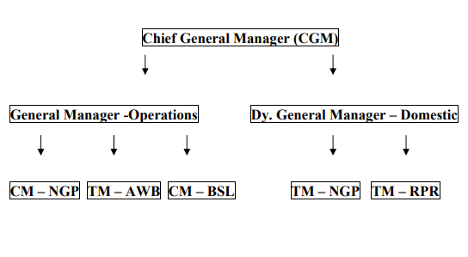
3.7, Problems faced by ICDs
3.7.1 Space and locations of inland container depots
The allocation a most efficient geographical location for an inland container depot is tiresome task, the function of an inland container depot itself requires it to have a location that specializes it in order to act as hinterland transportation unit. The inland container depot needs to placed in such a way that it lies closer to the various transportation mediums i.e. roadways and railways. Finding such a location for ICD in itself is a hard task.

3.7.2 Container traffic
Container traffic is a major element which makes the decision if or not to use the container depot, the container traffic right now being high does not affect the depot and the future prediction of it being on the rise also is a positive outlook for inland container depots, but if at all the container traffic decreases (as of any special case such as now because of the pandemic) it will affect the running of the inland container depot as their will be unnecessary cost occurrence in order to keep safe the already stored containers and because of no additional container incoming there will be no revenue earned.

3.7.3 ICD operation will increase the ability of the terminal service-
The increase of ability of the port also depends on the storage space available for it and therefore ICDs acting as an additional storage is a major help to the ports. This but has weak side too as the container that has to be stored in ICDs has to be transmitted to the ICDs from the terminal and therefore the access to ICDs should be easier and also closer to the terminal.
3.7.4 Additional amount of ICDs will increase the handling cost –
The increase in handling cost is major bad affect for ICDs. The containers to be transported from the terminals to the ICDs require transportation cost, handling cost , storage cost and other costs.
3.7.5 Yard Occupancy Ratio (YOR) The yard occupation ratio (YOR), a performance indicator of the container yard utilization is calculated using a general standard model. Furthermore, the paper forecasts the demand of the container yard using the growth method in order to evaluate the container yards capacity in the future. The yard occupancy ratio going down will affect the ICD badly.
3.7.6 Inadequate handling equipments and technology-
This is a common seen problem in most of the inland container depots the usage of inadequate handling equipments which will proportionally increase the cost incurred and also will damage the cargos. The following of traditional methods and not using the advanced technologies also results in inefficiency of the functions and procedures of an ICD.

CHAPTER- IV
PROFILE OF SELECTIVE ICDS IN INDIA
4.1 National Inland Container Depots
4.1.1 Inland Container Depot, Tughlakabad (TKD)
Spread across 55 acres of land in Tughlakabad and commissioned in 1993, ICD TKD is the largest dry port in Asia and serves as a focal point for most traders in North India. On an average, it handles nearly 2,000 containers a day. According to a report by the Indian Railways, ICD TKD handles approximately 60-70% more traffic than its capacity of about 2,50,000 TEUs/year
India’s largest ICD is clogged at all times. This leads to delays and thus, adversely impacts the businesses of those who use it. “There is a lot of traffic at this ICD. Vehicles hardly move and it takes nearly three days to load/unload containers. This delay hampers business. In Delhi, there is a huge ICD to cater to the needs of traders, but there is no separate corridor for the movement of vehicles to and from the depot. Trucks aren’t allowed to leave the premises during the day in order to avoid disruption to city traffic. This is one of the primary reasons for delays
4.1.2 Inland Container Depot, Dadri
CONCOR’s second largest ICD and a decade younger to ICD TKD, caters to both EXIM and domestic trade in the northern region of the country and has been designed to handle 5,00,000 TEUs per annum. Being a relatively new ICD, it also has four railway lines for easy transportation of goods from and to the ports. It is connected with all the three ports that ICD TKD currently caters to. Since the ICD is relatively new, it has lesser traffic, which makes it easier for my clients to transport goods through it.
4.1.3 Associated Container Terminal Limited (ICTL) in Faridabad

A private ICD operated by the R. R. Joshi Group has also emerged as a strong player in the area. Commissioned in 1997 it now also offers logistics support services such as freight forwarding, container repairing and in-house workshops. In fact, in September 2008, ACTL launched dedicated rail sidings and became the first private ICD to have rail lines. It, too, caters to JNPT, Mundra Port and Pipavav Port

4.1.4 Inland Container Depot, Adani Group’s, Gurgaon

The Adani Logistics Park (ALP) at Patli (Gurgaon) is spread over 73 acres of land and is technologically much more advanced as compared to all the other ICDs in the North. It has two railway sidings, with one engine escape line. It has a capacity to handle 2,00,000 TEUs annually and has been witnessing substantial growth in traffic in recent years.
Commenting on this trend, Sahai of FIEO said the rise of private players in the ICD sector is great news for the exporting community
4.1.5 Inland Container Depot (ICD), Nagpur
Nagpur is the central place, having immense scope for business, is connected with main stream of Rail to the East-West and North-South trunk Rail route, making it possible to run trains from & to all parts of India. It is also well connected to the National highway no. 6 (Mumbai-Kolkata) and National Highway No. 7 (Varanasi - Kanyakumari) and main linkage of Gate Way Ports. Inland Container Depot (ICD) at Nagpur caters to a large hinterland covering most parts of Maharashtra, Madhya Pradesh & Chhattisgarh in Central India. The “Service area” of the Inland Container Depot serves the industrial areas located at Yavatmal, Wardha, Butibori, Hingna, Mauda, Bhandara, Kalmeshwar, Raipur, Bhilai, Chhindwada, Saunsar and Rice Mills doting Chhattisgarh, Madhya Pradesh and Maharashtra, and having potential of Global business for EXIM Trade and Domestic Business in the Country. One of the well established and leading port in India, i.e. Jawaharlal Nehru Port Trust (former Nhava Sheva) is directly connected with this
Inland Container Depot at Nagpur made its modest beginning from January 1997 and providing various services required for “Single Window” clearance of containers and cargoes. It offers services of Custom Clearance for Export & Import Cargos, facility of Export & Import under various Export promotion Schemes, round the clock professional Security, handling and movement of Containers at factory site, special arrangement for Fumigation, palletisation and lashing of cargo, repair facility of containers, survey of containers from reputed Surveyors and modern communication facility. 25256 TEUs PER YEAR mean international.
4.1.6 Inland Container Depot, Aurangabad
ICD Maliwada started functioning from the year 1999 as a dry port.Inland Container Depot Maliwada is situated at village Maliwada in the midst of nature 22 Kms away from the Historic City Aurangabad and 4 Kms. distanced from famous DaulatabadThis ICD is a focal point for logistics infrastructure for international trade and also caters large hinterland covering most parts of Aurangabad and Marathwada Region. The “Service Area” of the ICD includes industrial areas located at Waluj, Chikhalthana, Chitegaon, Shendra, Paithan. ICD, Aurangabad is located at a distance of approximately 400 Kms from Ports of Mumbai. This ICD is rail linked with gateway ports of Mumbai Fort, popularly known as Devgiri Killa.
4.1.7 Inland Container Depot, Raipur
Raipur container depot was commissioned in year 2004. ICD is located near Railway good Shed, Kapa, Raipur, which is well connected with Rail/road on Raipur Bilaspur highway which is just 4 kms away from Raipur terminal. This ICD is 531 kms from Vizag Port, 971 kms from Haldia Port and 1153 Kms from Ports at Mumbai. There is immense scope for International and domestic trade at Raipur. This ICD has started with domestic business and looking forward to tap the business of entire chattisgarh. This ICD will offer schedule train services for major domestic destinations and also planning to honor with rail services for international trade also.
4.2 Suggestions
4.2.1 Marketing for exports and imports too is very essential to maintain the stability in the performance, example (ICD, Aurangabad is awarded by all facilities and infrastructure considering the business potential but growth in business is not satisfactory. To promote the business, it is recommended that extensive marketing is required at ICD, Aurangabad)
4.2.2 It is observed that adequate numbers of rakes for domestic business has not been allotted to ICD. It is recommended that to get the performance oriented result CONCOR should allot maximum numbers of train to ICD. It is also recommended that maximum numbers of domestic containers should be made available at ICD location, example (there was significant business growth but not steady at one instant at ICD, Aurangabad. The most important factor of business growth is consistency and to achieve consistency in business it is recommended that dedicated road and rail services should be provided for the transportation of imports & exports containers)
4.2.3 It is also observed that there is immense scope for agricultural and industrial EXIM business. In view to fulfill the trade’s growing requirement there should be at least one train per day at ICD.
4.2.4 it is recommended that CONCOR should start services for different ports so that importer / exporters will have more choices of different Ports than traditional JNPT/NSICT.
4.2.5 the unavailability of adequate inventory and irregular train services is one of the common problems faced by inland container depots therefore extending the railway network and making some only ICD oriented rail networks are necessary now. It is also recommended to understand trade’s requirement and scheduled services with guaranteed transit time should be offered to the trade to enable them to plan their shipment as per vessel.
4.3 ICDs in India
Table 4.1 Location of various ICDS in India
1 | Tughlakabad(TKD) | New Delhi | Haryana
2 | Sanathnagar(SNF) | Hyderabad | Andhra Pradesh
3 | Anarpati | East Godavari(AP) | Andhra Pradesh
4 | Nagpur | Nagpur | Maharashtra
5 | Coimbatore | Coimbatore | Tamil Nadu
6 | Tondiarpet | Chennai | Tamil Nadu
7 | Agra | Belanganj | Uttarpradesh
8 | Moradabad | Moradabad | Uttarpradesh
9 | Guntur | Guntur | Andhra Pradesh
10 | New Mulund(E) | Mumbai | Maharashtra
11 | Whitefield | Bangalore | Karnataka
12 | Chirala | Dist Guntur(AP) | Andhra Pradesh
13 | Sabarmati | Ahmedabad | Gujarat
14 | Amingaon | Guwahati | Assam
15 | Madurai | Madurai | Tamil Nadu
16 | Dhandarikalan | Ludhiana | Punjab
17 | Kanpur | Kanpur | Uttar Pradesh
18 | Daulatabad | Aurangabad | Maharashtra
19 | Cossipore | Kolkata | West Bengal
20 | Jodhpur | Jodhpur | Rajasthan
21 | Kanakpura | Jaipur | Rajasthan
22 | Miraje | Miraje | Maharashtra
23 | Balasore | Balasore | Orissa
24 | Bhusawal | Bhusawal | Maharashtra
25 | Riwari | Haryana | Haryana
26 | Dadri(Greater Noida) | Delhi | Haryana
27 | Raipur | Khapa | Madhya Pradesh
28 | Tirupur | Tirupur | Tamil Nadu

4.4 Challenges and opportunities of ICDs
India is a country in the development stage, we are a developing country. The Nature of ICDs in India is also of the same nature, it is still in the developing stage and therefore it has its own challenges and thereby developments through those challenges in the future. The most resourceful country in the world and also having one of the largest working forces in the world India does not come last in any way but the major drawback is seen in the logistics and imports and export business in India.
ICD has been established in India from the 1990s and is one of the industries that have not gone through much changes or developments in the years. ICDs are a backbone to sea ports in India; ICDs support the sea ports by providing storage space, administrative help, transshipments, and logistics help in domestic and international etc.
Challenges –There are no dedicated transport lines for ICDs and so the transporting time always is delayed, having dedicated transport lines will avoid the unwanted traffic faced by transportation done by roadways and also providing dedicated raillines will ensure the quick transfer of containers from the port to the ICD and also easier and faster transmission of cargos within the domestic range.
No nearby industries is also a major drawback as having industries nearby will allow to increase business and to speed up the processes involved in the transportation and can help in following the just in time approach in logistics.
The functions provided by ICDs are also not upto mark, the delay in administrative clearance and the inefficiency in clearance of incoming cargo and also the slow and steady attitude to the outbound shipments etc all add to the backdrop the ICDs. The quality of storage is also another function we need to look into as providing the best quality storage is one of the basic requirements from an ICD.
Opportunities- A rising trend is seen in the container traffic at major ports in India in the past 5-6 years, and the container traffic has a growth of 13% every year. This will directly impact the usage of ICDs. Government investments in ICDs are also being implemented and CONCOR has invited private parties to take up and run some of the ICDs owned by them which will be a result in major investments and developments in the ICD sector.

CHAPTER- V
CONCLUSION

5.1 Conclusion
Inland container depot plays a key role in the economy of a country in that it supports the movement and flow of cargos. It is an important activity with regard to the facilitation of goods... If goods do not arrive in the correct place or condition, no sale can be made. Major role played by dry port to be noted is the mediator role it plays for hinterland regions. Nowadays we see that the goods are exported or imported by containers, all types of cargo has become containerized since it is a more safer and economical means of transporting cargo and therefore the need of inland container depots will be on a rise in the future. Researches and study on how to make a efficient inland port through development in infrastructure, functions and technology are being done.
This project on inland container depots covers, the explanation about functions involved in an inland depot, a list on depots in India, briefings on some of the well known dry ports in the world and also the challenges and opportunities that lie ahead in the future for inland ports. By going through this project you will understand clearly what an inland depot is and its value in relation to logistics and shipping.
Overall, the project covers the objectives in a precise manner explaining in simple words the various sides of dry ports and the problems related with them.
5.2 Covid-19 affecting ICDs
The current pandemic situation has affected various functions, economic zones and many other operations, one of them being ICDs. The ICDs has been affected in a serious manner or in wider aspect the whole countries growth has come to a halt.
India’s exports shrank almost 35% in March, the biggest contraction in almost a decade, reflecting the global slowdown made worse by the Covid-19 pandemic. Exporters looking to restart operations are confronted with multiple issues including additional costs due to stringent norms, cash flows and getting labour back to work.
Import containers have piled up at ports as manufacturing of non-essential goods is yet picking up under the lockdown, prompting some ports to shut export gates.
India’s exports shrank almost 35% in March, the biggest contraction in almost a decade, reflecting the global slowdown made worse by the Covid-19 pandemic.
Exporters looking to restart operations are confronted with multiple issues including additional costs due to stringent norms, cash flows and getting labour back to work.
A countries development status is known by the amount of exporting done and the logistics efficiency. Logistics place a major role in meeting up the needs of the wide range of consumers of the nation, and in providing them with their needs the nation builds up its successful economy.
This pandemic has affected all the processes and operations to complete halt that starting up again will really be a tough process.
Shipping lines
The announcement follows an order issued by the Director General (DG) of Shipping on Saturday, advising shipping lines not to impose container detention charges on import shipments till April 7 “for the smooth functioning of trade and maintenance of supply chain in the country”.
India’s maritime regulator acknowledged that some delays in evacuation of goods from the ports have become inevitable due to the disturbance of downstream services.
“As a result of these developments, some cargo owners have either suspended their operations or are finding it difficult to transport goods/cargo and complete the paper work, resulting in detention of containers without their fault”
Maersk Line said the blanket detention free time is applicable only to imports into India and Nepal. It also covers shipments to inland container depots (ICDs).
Some cargo owners will temporarily cease operations or face challenges in transportation and documentation procedures during this period resulting in the disruption of imports and exports, the company said.
“As a special concession to our customers during these challenging times, we will not be charging container detention on all our import shipments into India for the period from 25 March to 7 April (both days inclusive). This will be over and above any existing free time arrangement that is currently availed and agreed as a part of any negotiated contractual terms,” Maersk said in a March 27 customer advisory.
This concession is a one-off gesture during this period for our customers. In the current situation, all partners in the supply chain face significant challenges
Customers who are paying demurrage and/or container freight station (CFS) ground rent charges directly (Ex: direct port delivery or DPD customers) will have to handle this directly with the respective Port/ CFS. In cases where customers are paying demurrage/ ground rent charges via Maersk, then we will endeavour to pass through any waiver/ concessions received by these Port/CFS to our customers”, it added.

5.3, Bibliography
https://www.financierworldwide.com
http://kerryindev.com
https://www.translog.in
https://link.springer.com
http://www.nzdl.org
https://www.saloodo.com
http://agriexchange.apeda.gov.in
https://ctl.mit.edu
https://www.business-standard.com

5.4, Figures

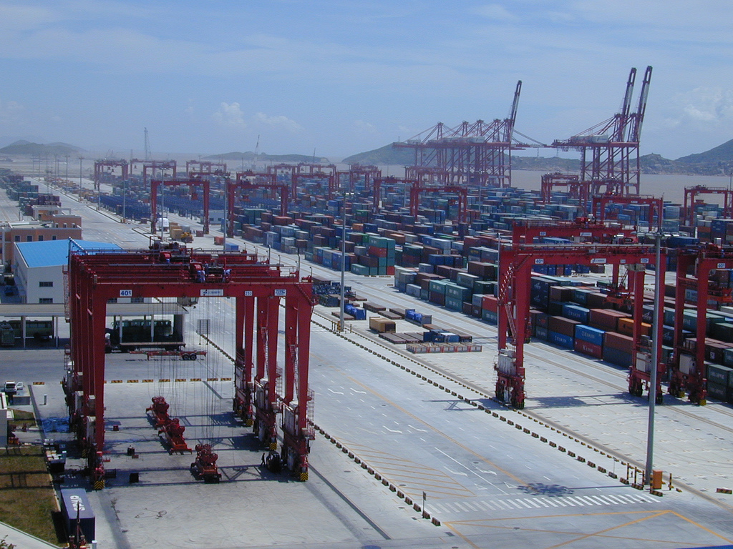
5.1) Port of Shanghai

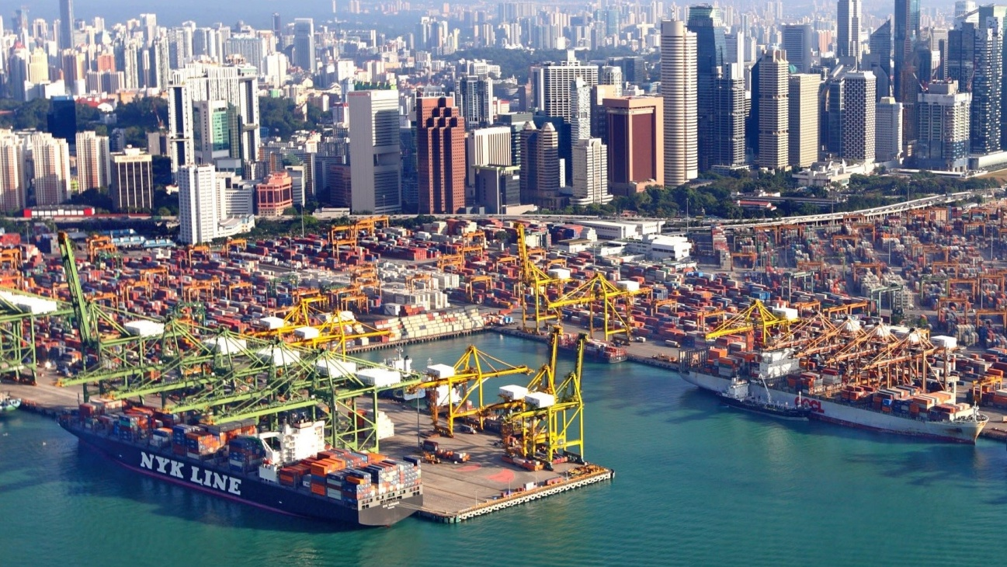
5.2) Figure Port of Singapore
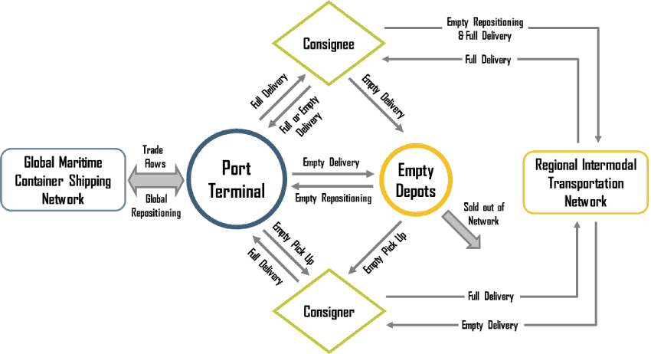
5.3) Repositioning of empty containers

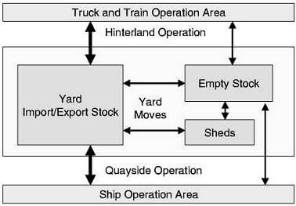
5.4) Structure of container depots

